SMS System

📱 What is an SMS System?
# Source: AI Source: Provided by: [Data Path: Persons Table -> ID Column: 1, Name_En Column: Motasem Essam] -> From: [ChatGPT] on [1/21/2026]
An SMS system is a software or hardware setup that enables the sending and receiving of Short Message Service (SMS) messages — also known as text messages — over mobile networks.

🔧 Components of an SMS System
# Source: AI Source: Provided by: [Data Path: Persons Table -> ID Column: 1, Name_En Column: Motasem Essam] -> From: [ChatGPT] on [1/21/2026]
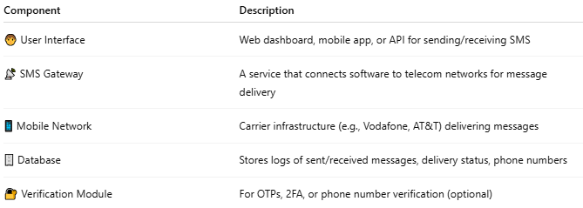

Component | Description
🧑 User Interface | Web dashboard, mobile app, or API for sending/receiving SMS
📡 SMS Gateway | A service that connects software to telecom networks for message delivery
📱 Mobile Network | Carrier infrastructure (e.g., Vodafone, AT&T) delivering messages
🗄️ Database | Stores logs of sent/received messages, delivery status, phone numbers
🔐 Verification Module | For OTPs, 2FA, or phone number verification (optional)

🔁 How It Works (Flow)
# Source: AI Source: Provided by: [Data Path: Persons Table -> ID Column: 1, Name_En Column: Motasem Essam] -> From: [ChatGPT] on [1/21/2026]
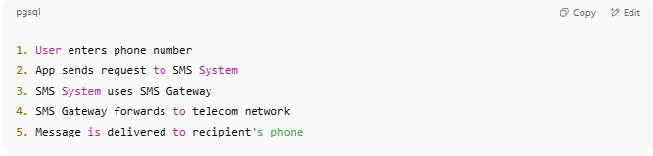
1. User enters phone number
2. App sends request to SMS System
3. SMS System uses SMS Gateway
4. SMS Gateway forwards to telecom network
5. Message is delivered to recipient's phone

💡 Common Use Cases
# Source: AI Source: Provided by: [Data Path: Persons Table -> ID Column: 1, Name_En Column: Motasem Essam] -> From: [ChatGPT] on [1/21/2026]
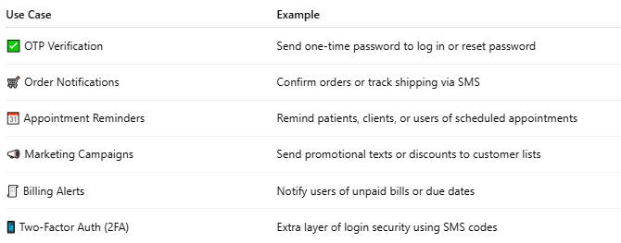

Use Case | Example
✅ OTP Verification | Send one-time password to log in or reset password
🛒 Order Notifications | Confirm orders or track shipping via SMS
📆 Appointment Reminders | Remind patients, clients, or users of scheduled appointments
📣 Marketing Campaigns | Send promotional texts or discounts to customer lists
🧾 Billing Alerts | Notify users of unpaid bills or due dates
📱 Two-Factor Auth (2FA) | Extra layer of login security using SMS codes

📡 Types of SMS by Delivery Infrastructure:
# Source: AI Source: Provided by: [Data Path: Persons Table -> ID Column: 1, Name_En Column: Motasem Essam] -> From: [ChatGPT] on [1/21/2026]
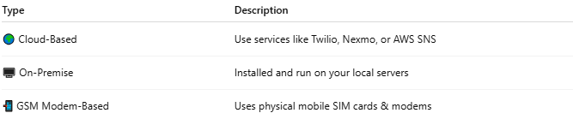

Type | Description
🌍 Cloud-Based | Use services like Twilio, Nexmo, or AWS SNS
🖥️ On-Premise | Installed and run on your local servers
📲 GSM Modem-Based | Uses physical mobile SIM cards & modems

🔌 Popular SMS APIs & Services
# Source: AI Source: Provided by: [Data Path: Persons Table -> ID Column: 1, Name_En Column: Motasem Essam] -> From: [ChatGPT] on [1/21/2026]
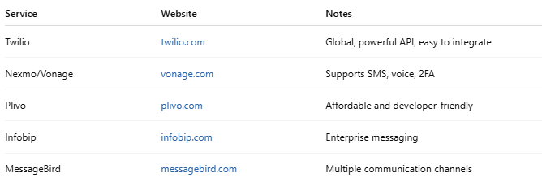

Service | Website | Notes
Twilio | twilio.com | Global, powerful API, easy to integrate
Nexmo/Vonage | vonage.com | Supports SMS, voice, 2FA
Plivo | plivo.com | Affordable and developer-friendly
Infobip | infobip.com | Enterprise messaging
MessageBird | messagebird.com | Multiple communication channels

